DBMS Lab 7 Demo

Introduction
Definition - A transaction is a logical unit of work that contains one or more than one SQL statements where either all statements will succeed or all will fail. The intermediate states between the steps are not visible to other concurrent transactions, and if some failure occurs that prevents the transaction from completing, then none of the steps affect the database at all.

A transaction is a single logical unit of work that interacts with the database, potentially modifying its content through read and write operations. To maintain database consistency both before and after a transaction, specific properties, known as ACID properties must be followed.

Properties
- Atomicity – This property ensures that all the operations of transactions are complete. It follows all or none property.
- Consistency – This property ensures that after all the transactions database is in consistent state, i.e after committing the transaction those changes are properly updated in the database or not.
- Isolation – When two transactions are running then both the transactions will have their own privacy i.e one transaction won’t disturb another transaction.
- Durability – This property ensures that even at the time of system failures the committed data in the database is secure i.e permanently.

Commands
- BEGIN - It is used to start a transaction block.
- COMMIT - It is used to save changes to the database.
- ROLLBACK - It undoes the changes that were issued in the transaction block before it.
- SAVEPOINT - It helps in defining boundary within a transaction that allows for a partial rollback.It also gives the user the ability

Procedures
In PostgreSQL, a procedure is a database object that allows you to encapsulate SQL statements and logic for execution on the server side. Unlike functions, procedures are designed for performing actions rather than returning values.
Syntax
CREATE PROCEDURE procedure_name (param1 data_type, param2 data_type, ...)
LANGUAGE plpgsql
AS $$
BEGIN
-- Procedure logic here
END;
$$;
Procedure with Loop and Logic
CREATE PROCEDURE generate_numbers(limit INT)
LANGUAGE plpgsql
AS $$
DECLARE
counter INT := 1;
BEGIN
WHILE counter <= limit LOOP
INSERT INTO numbers_table(value) VALUES (counter);
counter := counter + 1;
END LOOP;
END;
$$;
CALL generate_numbers(10); # calling the procedure
DROP PROCEDURE procedure_name; # drop command
Examples
--1. BEGIN-SAVEPOINT-COMMIT
BEGIN;
CREATE TABLE BankAccountDetails ( customer_id serial PRIMARY KEY,
customer_name VARCHAR NOT NULL,
balance INT NOT NULL CHECK(balance > 0)
);
INSERT into BankAccountDetails(customer_name,balance) Values('Ram',100000);
INSERT into BankAccountDetails(customer_name,balance) Values('Shyam',200000);
SAVEPOINT first_savepoint;
DELETE from BankAccountDetails;
ROLLBACK TO first_savepoint;
COMMIT;
select * from BankAccountDetails;

This code demonstrates transaction control where changes are grouped using BEGIN and finalized with COMMIT. The SAVEPOINT creates a checkpoint, allowing a partial rollback to undo the deletion while preserving the earlier inserts. This approach ensures data consistency and controlled error recovery, aligning with ACID principles.

--2.BEGIN-ROLLBACK
BEGIN;
UPDATE BankAccountDetails SET balance = balance - 10
WHERE customer_name = 'Shyam';
ROLLBACK;

select * from BankAccountDetails;

This code starts a transaction with BEGIN, updates Shyam's balance by deducting 10, and then rolls back the change using ROLLBACK. Since no COMMIT occurs, the update is discarded, and the table remains unchanged.

--3. BEGIN-COMMIT
BEGIN;
UPDATE BankAccountDetails SET balance = 200
WHERE customer_name = 'Shyam';
UPDATE BankAccountDetails SET balance = -1
WHERE customer_name = 'Ram';
COMMIT;

select * from BankAccountDetails;
This code starts a transaction with BEGIN, updates Shyam's balance to 200, and attempts to set Ram's balance to -1. Since the CHECK(balance > 0) constraint is violated, the second update fails, causing the entire transaction to fail. As a result, neither change is applied, and the table remains unchanged after the COMMIT.

--4. Transaction Management inside Procedure
CREATE PROCEDURE transaction_test(id int)
LANGUAGE plpgsql
AS $$
DECLARE cust_id int := id;
BEGIN
raise notice 'customer_id is %', cust_id;
UPDATE BankAccountDetails SET balance = balance + 300000 WHERE customer_id = cust_id;
commit;
cust_id := cust_id + 1;
raise notice 'customer_id is %', cust_id;
UPDATE BankAccountDetails SET balance = balance + 100000 WHERE customer_id = cust_id;
commit;
cust_id := cust_id + 1;
raise notice 'customer_id is %', cust_id;
UPDATE BankAccountDetails SET balance = balance + 1000000 WHERE customer_id = cust_id;
END;
$$;
CALL transaction_test(1);
--DROP PROCEDURE transaction_test;
select * from BankAccountDetails;

This procedure updates balances in steps, committing after each update. It adds 300,000 to customer 1, 100,000 to customer 2, and attempts to add 1,000,000 to customer 3. Since the final update lacks a COMMIT, it remains uncommitted and will be discarded if the session ends or rolls back.

Resources
1. https://www.postgresql.org/docs/8.3/tutorial-transactions.html
2. https://www.enterprisedb.com/postgres-tutorials/how-work-postgresql-transactions
3. https://www.postgresql.org/docs/11/plpgsql-transactions.html

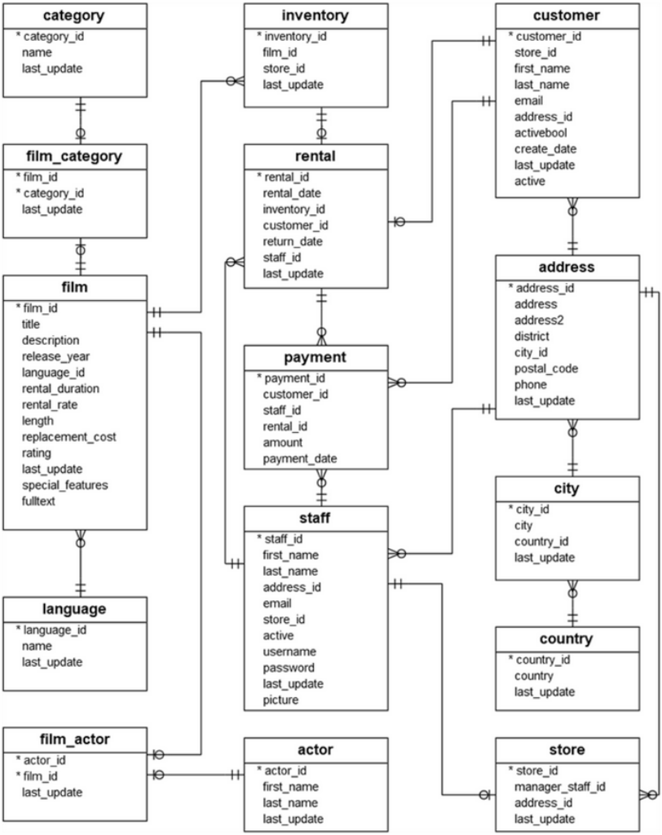

Q1. Answer

CREATE PROCEDURE rent_movies(
IN p_inventory_id INT,
IN p_customer_id INT,
IN p_staff_id INT
)
LANGUAGE plpgsql
AS $$
BEGIN
-- Check if the customer exists
IF NOT EXISTS (
SELECT 1 FROM customer WHERE customer_id = p_customer_id
) THEN
RAISE EXCEPTION 'Transaction failed: Customer ID % does not exist.', p_customer_id;
END IF;

-- Check if the inventory item exists
IF NOT EXISTS (
SELECT 1 FROM inventory WHERE inventory_id = p_inventory_id
) THEN
RAISE EXCEPTION 'Transaction failed: Inventory ID % does not exist.', p_inventory_id;
END IF;

-- Check if the movie is already rented
IF EXISTS (
SELECT 1
FROM rental
WHERE inventory_id = p_inventory_id
AND return_date IS NULL
) THEN
RAISE EXCEPTION 'Transaction failed: Movie is already rented.';
ELSE
-- Insert rental record
INSERT INTO rental (rental_date, inventory_id, customer_id, return_date, staff_id)
VALUES (CURRENT_DATE, p_inventory_id, p_customer_id, NULL, p_staff_id);

RAISE NOTICE 'Transaction successful: Movie rented.';
END IF;
END;
$$;

call rent_movies(1,101,1)

